**MADE BY SHARON MISHRA**

**Design Document for Artisan and User App**

**FIGMA LINK :**-https://www.figma.com/design/GlgDQnRDAuHSUqkJMvb6to/Untitled?node-id=0-1&t=uQZ2KBk4C2mQPmvl**-1**

**1. Application Overview**

The app connects artisans and users (customers) to facilitate service bookings. Artisans

manage their profiles, bookings, and interactions with users. Users can browse artisan

profiles, view charges, and book services.

**Dual Flow Structure**

Upper Flow: For artisans (top row of the design).

Lower Flow For users (bottom row of the design).

User Registration: Simplified with Google Sign-Up only.

**2. Screen Flow and Features**

**Artisan Flow (Upper Flow)**

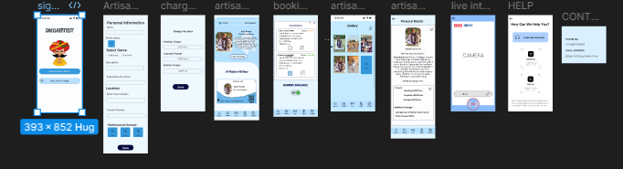

***Artisan Sign-Up***

Artisans provide service details, including genre, location, and performance samples. They

register by filling forms and uploading portfolio media.

***Artisan Dashboard***

***A control center displaying bookings, charges, and access to profile editing and gallery management.***

***Key Features:***

***- Update Profile***

***- Manage Bookings***

***- Navigate to Gallery and Live Sessions***

***Artisan Profile***

A detailed profile showcasing artisan services, skills, location, and portfolio. This is editable

by artisans and viewable by users.

***Gallery***

Displays uploaded images or videos of the artisan's work for users to view. Artisans can

manage media to highlight their expertise.

***Live Interaction***

Allows artisans to host live sessions to promote services or interact with users in real time.

***Help & Contact (Artisan)***

Support for artisans to address profile or app issues. Includes FAQs, contact support (email

or phone), and chat assistance.

**User Flow (Lower Flow)**

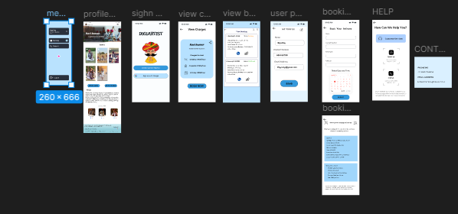

***Google Sign-Up***

Simplifies registration for users. Users sign up with a Google account and are redirected to

the home screen.

***Home Screen***

Central navigation for users with options to:

Check service pricing before booking. . Select and schedule a service.

view charges, and book services.

***View Charges***

Allows users to check pricing details before proceeding to book a service. Helps users make

informed decisions.

***Book a Service***

Users can schedule services with artisans by selecting service type, date, and time, and

entering details.

***View Bookings***

Displays current and past bookings with status updates (confirmed, pending, etc.).

***Help & Contact (User)***

Provides users with support for booking or app-related queries. Includes FAQs, chat

support, and direct contact options.

**3. Color Scheme**

**Primary Colors**

1. Light Blue (#B6E1FF):

- Background for screens and side menu bar.

- Purpose: Calm and inviting tone for both artisans and users.

2. White (#FFFFFF):

- Background for forms, cards, and input fields.

- Purpose: Clean and modern for high readability.

**Secondary Colors**

1.Dark Blue (#00008B):

- Button backgrounds (e.g., Save, Book Now).

- Purpose: Highlights important actions.

2. Gray (#A9A9A9):

- Text for secondary content (e.g., placeholder text).

- Purpose: Ensures subtle, non-distracting details.**Accent Colors**

**4. Design Rationale**

**Artisan Flow Design Choices**

Goal: Provide artisans with tools to manage profiles and bookings efficiently.

Why: To empower artisans to market their services effectively and build trust with users.

**User Flow Design Choices**

Goal: Enable users to discover, evaluate, and book artisans with ease.

Why: Users require a seamless process for service discovery and booking to ensure

satisfaction.